SOUTHWEST PRE EMPLOYMENT TRUCK APPLICATION
Our Company is an equal opportunity employer and will consider all applicants for all positions equally without regard to their race, sex, age, color, religion, national origin, veteran status, genetic information or any disability as defined in the Americans With Disabilities Act, or for any other reason protected by State or Federal law.
This application will be given every consideration, but its receipt does not imply that the applicant will be employed. Each question should be answered in a complete and accurate manner as no action can be taken on this application until all questions have been answered.

PERSONAL INFORMATION

Date___
Name:Click or tap here to enter text. |  |  |  | Home Phone:Click or tap here to enter text.
LAST  Cell Phone:Click or tap here to enter text.  Present Address:____________________ | FIRST  E-Mail Address:__ | MIDDLE
How long have you resided at this address?______Click or tap here to enter text.
Social Security Number:____________ Are you 18 years of age or older? Yes C) No
Are you a citizen of the U.S. or do you have the legal right to be employed in the United States? Yes No
Do you have the ability, with or without reasonable accommodations, to work overtime or to travel if travel and/or overtime are required by the job for which you are applying? Yes l No
If No, please explain_____________________________________________________________________________________
Are you subject to any non-compete, non-disclosure or confidentiality agreements, or any other type of agreement with any current or former employer(s) or organization(s) which would limit your ability to work for our company? Yes C) No
If yes, please explain:
(Note: You may be required to provide a copy of any such agreement)
Driver’s License: State____ Type_____ Currently Valid? Yes /No
Would you be willing and able to relocate? Yes /No

EMPLOYMENT DESIRED
Are you seeking full time, part time, temporary or summer employment? Position applied for?_ Salary Desired_____________
Date available to start_____________
Have you ever applied to our company before? Yes /No Have you ever worked for our company before? Yes/No
If your answer to either of the above questions is Yes, state when and where you applied and/or worked.
______________________________________________________________
How did you learn of our company and/or position?_______________________________
Are you now, or do you expect to be, working in any other business or job? Yes No
Are there any days or hours you would be unable or unwilling to work? Yes No
If Yes, please specify those days and hours you would be unable or unwilling to work_______________
Is there any type of work which you will not perform? a Yes No
If Yes, please explain_______________________________________
Name, Address and Location Graduate? Courses Studied
High School/GED  Click or tap here to enter text. | Circle highest  Grade completed  9 10 11 12 | Yes  No | Diploma:Click or tap here to enter text.
College  Click or tap here to enter text. | Circle number of years completed  1 2 3 4 | Yes  No | Major: _________________  Minor:____________  Degree(s):
Trade School | Number of months attended  ___________ | Yes  No | Diploma or Certificate:_______________________
If you did not graduate, why did you leave high school or college?
_____________________________________
Are you planning to pursue further studies? Yes No If so, when, where and what courses?_________________

- List any scholastic honors, offices held and activities involved in during high school and college. (Please exclude those which may reflect race, sex, color, religion, national origin, disability, sexual orientation or other protected status)
- _____________________________

Please describe any other special courses, seminars or training which may enable you to better perform the duties of the position for which you are applying._____________________________________
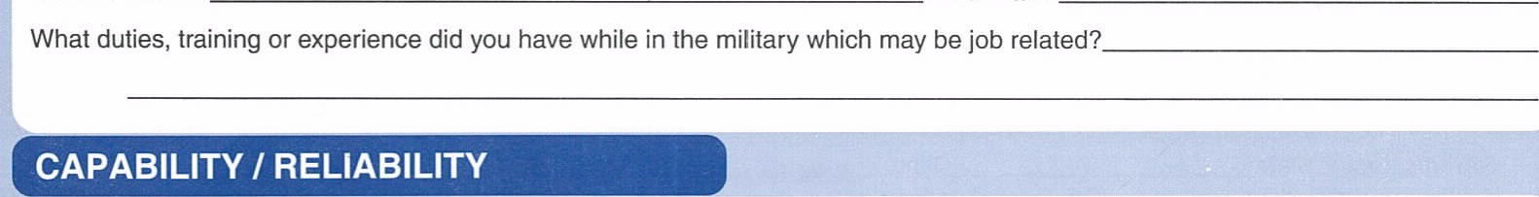
Service
Branch
Final
Rank
Have you ever served in the Military
?
Yes
No
Would you be willing and able to perform all of the tasks required by the job you are applying for? Cl Yes No If not, explain which tasks
Have you filed any type of fraudulent claim against any of your present or past employers? Yes No
If Yes, please explain
______________________________________________
Will you abide by the safety rules of this company? Yes C) No
Have you ever been disciplined for violating company safety rules or regulations? Yes C) No
If Yes, please explain______________________________
How many days of work (or school) have you missed in the last two years?_____________
How many times have you been late for work (or school) in the last two years?____________
Consistent attendance and punctuality are essential requirements of every job in our company. Would you be willing and able to report to work on time every day on a regular and consistent basis? Yes No
If No, please explain______________________________________
Have you ever been disciplined or received verbal or written warnings for absenteeism or tardiness? Yes ] No If Yes, please explain._____________________________________________________
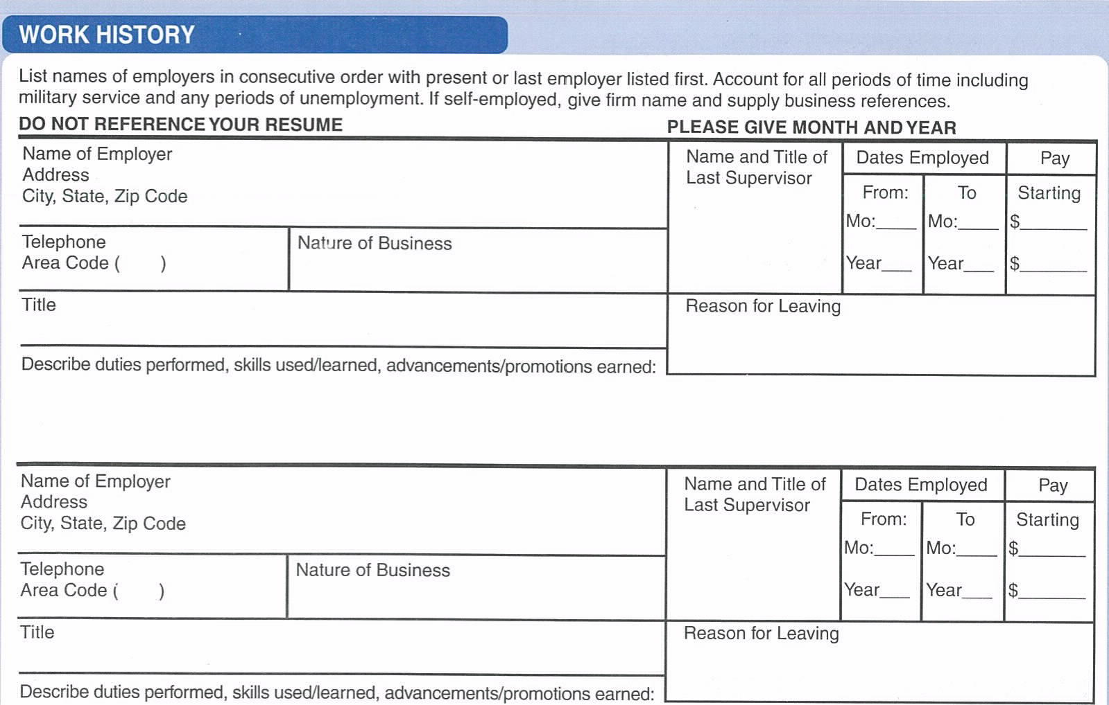
Name of Employer____________________________________  Address_______________________________________  City, State, Zip Code___________________________________ |  |  | Name and Title of Last Supervisor________________ |  | Dates Employed |  |  |  | pay
 |  |  |  |  | From:____  Year______ |  | To____  Year___ |  | Starting  ______  Ending  ________
Telephone  Area Code (Click or tap here to enter text. | Nature of BusinessClick or tap here to enter text.
TitleClick or tap here to enter text. |  |  | Reason for Leaving  Click or tap here to enter text.
Describe duties performed, skills used/learned, advancements/promotions earned:____________________
Name of Employer_______________________  Address____________________________  City, State, Zip Code__________________ |  |  |  | Name and Title of Last Supervisor  Click or tap here to enter text. |  | Dates Employed |  |  |  | Pay
 |  |  |  |  |  | From:  _______  Year_____ |  | To MO:_____  Year____ |  | Starting  $_________  $_________
Telephone  Area Code (______________ |  | Nature of Business  ____________________
TitleClick or tap here to enter text. |  |  |  | Reason for Leaving  Click or tap here to enter text.
Describe duties performed, skills used/learned, advancements/promotions earned:

SUPPLEMENTAL INFORMATION
If you worked in any of your previous positions under another name, please give that name(s) below: (For reference checking purposes)
Name________________ @ Company Name @ Company
Are you presently employed? a Yes No If yes, may we contact your present employer? Yes No Please list all periods of time since high school or college during which you were not employed
How did you spend this time?_____________________________________________
What languages do you speak fluently?_____________________________________

SPECIAL SKILLS
Do you type? Yes No Words Per Minute
Please list all software programs in which you are proficient, indicating how many years work experience you have with each:________________________________________________________________________________
List other computer skills, programming languages, or computer training you have had:___________________________
List other technical training, skills or work experience which may qualify you for a job with us:______________________________
Use this space below to describe why you are interested in working for our company and to list those skills and abilities which you feel particularly qualify you or a position with us. If you need more space, please continue on a separate sheet.__________
Give three references, not relatives or former employers
NAME | ADDRESS | PHONE | OCCUPATION
Click or tap here to enter text. | Click or tap here to enter text. | Click or tap here to enter text. | Click or tap here to enter text.
Click or tap here to enter text. | Click or tap here to enter text. | Click or tap here to enter text. | Click or tap here to enter text.
Click or tap here to enter text. | Click or tap here to enter text. | Click or tap here to enter text. | Click or tap here to enter text.

AFFIDAVIT
I certify that my answers to the foregoing questions are true and correct without any consequential omissions of any kind whatsoever. I understand that if I am employed, any false, misleading or otherwise incorrect statements made on this application form or during any interviews may be grounds for my immediate discharge.
I hereby authorize the Company to contact any company or individual it deems appropriate to investigate my employment history, education, character and qualifications and I give my full and complete consent to their revealing any and all information they wish as a result of this investigation. In addition, I hereby waive my right to bring any cause of action against these individuals for libel, slander, defamation, invasion of privacy or any other reason because of their statements.
I agree that, if I am employed, I will abide by all the rules and regulations of the Company. I understand that the taking of drug and alcohol tests, when given pursuant to company policy, are a condition of continued employment and refusal to take such tests when asked will be grounds for my immediate termination. I also acknowledge that, if I am employed, it is my affirmative responsibility to report to management any evidence of sexual or other illegal forms of harassment immediately. I further understand that nobody in the Company is authorized to enter into any written or verbal employment contracts with me for any definite period of time without the express written consent of the President of the Company. I also understand that my employment is at-will and may be terminated by myself or by the company at any time for any reason or no reason at all, with or without prior notice.
Signature Date
Company Use Only Interviewed by:
Interviewers remarks:
Is the operation of a company vehicle a job requirement? Yes
If yes to above, has a request for driver's record been made? Yes
Copyright 2013, Whiting & Associates, Inc. All rights reserved. Form APP. 910 To reorder; call 972-492-0895.
Whiting & Associates, Inc. has made every effort to insure compliance with Federal and State regulations, however, we assume no responsibility for the use of this form.

